MILEN T. STANEV, Assoc. AIA
Job Captain | Architectural Designer | Architect Technician
• Email: milents85@gmail.com • Cell: (206) 910-4656 • Portfolio: www.milenstanev.myportfolio.com

PROFESSIONAL EXPERIENCE:
JOB CAPTAIN @ THE DESIGN COLLECTIVE, Seattle, WA 04/2018-10/2020
Responsibilities: Assisting Principal/PM with: • Management of the technical and production aspects of all project phases • Codes, ordinances, and materials researches • Staffing, estimating, scheduling, proposals, and budgets • Coordination of projects with the stakeholders involved • Construction administration - Site visits & reports, ASI's, RFI's, Submittals • Improving & developing BIM/CAD standards • Managing small teams for variety of assignments
Project types I have been involved with: • Mixed-Use • Residential • Commercial
Highlighted Projects: • Silver Cloud Hotel at Point Ruston, Tacoma, WA – 229,663 GSF • Franklin Apartments, Seattle, WA – 7,133 GSF • Pehling DDS Clinic Remodel, Seattle, WA – 1,662 GSF • Feasibility Analysis of a High-rise, Mixed-use building, Seattle, WA – 86,760 GSF
ARCHITECTURAL / MEP/ BIM/ CAD DRAFTER @
MODERN CONSTRUCTION SERVICES, Seattle, WA 01/2016-03/2018
Responsibilities: Assisting VCS PM with: • Handling the technical and production aspect of the architectural projects • Production of Revit/AutoCAD backgrounds, Revit families, and AutoCAD blocks designated to support the coordination process • BIM modeling of mechanical and plumbing fabrication models and production of related 2D plans, sections and shop drawings • Quality control which included investigation of architectural and structural project documentations for inconsistency or mistakes and reporting to the PM involved • Attending coordination meetings, leading the clash detection process, and was generating clash reports using Navisworks Manage.
Project types I have been involved with: • Mixed-Use • Residential • Commercial • Hospitality • High-Rise
Highlighted Projects: • Facebook office - Dexter Station - 335,000 GSF • Environmental Learning Center - Tacoma zoo - 30,095 GSF • Nike world headquarters campus expansion - 466,824 GSF • Google office - Kirkland - 187,624 GSF • Transbay Block 8 - San Francisco - 767,051 GSF • Computer science and engineering expansion - UW Seattle - 138, 770 GSF
ESTIMATOR | SUPERINTENDENT | ARCHITECT @
ENGINEERING SYSTEMS, Sofia, Bulgaria 2014-2015
ESTIMATOR | ARCHITECT @ HSS GROUP, Sofia, Bulgaria 2013-2014
PROJECT ARCHITECT @ BUREAU VASILEV, Sofia, Bulgaria 2009-2013
Responsibilities: Assisting Principal/PM with: • Management of the technical and production aspects of all project phases • Codes, ordinances, and materials researches • Estimating, scheduling, proposals, and budgets
• Coordination of projects with the stakeholders involved • Construction administration - Site visits & reports, ASI's, RFI's, Submittals • Improving & developing BIM/CAD standards
Project types I have been involved with: • Industrial Buildings • Warehouses • Mixed-Use • Residential • Other
Highlighted Projects: • Furniture store COMO- 123,699 GSF • Production Base of Zobele Bulgaria LTD - 197,700 GSF • Storage of Elit Imoti JSC - 86,111 GSF
JUNIOR ARCHITECT @ PROARCH, Sofia, Bulgaria 2007-2009
Responsibilities: Assisting Principal/PM with: • Technical and production aspects of all project phases
• Materials researches • Scheduling • Coordination meetings of projects with the stakeholders involved
Project types I have been involved with: • Mixed-Use • High-Rise • Residential • Commercial • Other
Highlighted Projects: • Park Tower – Multifunctional trade and office complex - 279,862 GSF
• Leon Tower - Multifunctional office and hotel complex - 667,362 GSF
PERSONAL ATTRIBUTES: • Organized and detail oriented • Critical and Out of the Box Thinking • Problem solving • Flexible & Dependent • Motivated • Collaborative
TECHNICAL SKILLS: • Revit • AutoCAD • Archicad • SketchUp • BIM 360• Bluebeam Revu • Adobe Creative Suite
• Microsoft Office Suite • PowerPoint • Navisworks Manage • MS Project • AutoCAD Fabrication • Plan Grid • Lumion • 3D Max • Twinmotion • AutoCAD AutoLisp • AutoCAD ActiveX
HOBBIES: • Photography • Traveling & Exploration • Innovations & New technologies • Sport • Improving & Developing of Personal Skills Set & Knowledge
EDUCATION:
• Master of Architecture (2012) - Eligible for NCARB AXP and ARE
• Master of Structural Engineering (2011)
University of Structural Engineering & Architecture (VSU) "Lyuben Karavelov" - Sofia, Bulgaria
PROFESSIONAL ORGANIZATIONS & CERTIFICATIONS:
• Autodesk Certified Professional: Revit for Architectural Design
• National Council of Architectural Registration Boards ( NCARB ) - 3,658.75 AXP hours out of 3,740 completed
• Volunteering Member of the Seattle International Architecture Forum (SIAF) AIA Committee
• The American Institute of Architects ( AIA )
• Licensed Architect by Chamber of Architects in Bulgaria
RECOMMENDATIONS:
• Job Captain @ The Design Collective, Seattle, WA - 04/2018-10/2020 – Page 3
• Architectural / MEP/ BIM/ CAD Drafter @ Modern Construction Services, Seattle, WA – 2016-2018 – Page 4
• Estimator | Superintendent | Architect @ Engineering Systems, Sofia, Bulgaria - 2014-2015 – Page 5
• Project Architect @ Bureau Vasilev, Sofia, Bulgaria - 2009-2013 – Page 6

JOB CAPTAIN @ THE DESIGN COLLECTIVE, Seattle, WA 04/2018-10/2020
Scott Becker, Principal: Cell: 206-533-9112, Email: scottb@thed-c.com
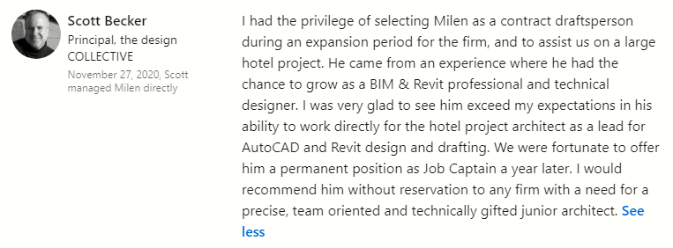
Michael Cox, Associate: Cell: 206-390-3966, Email: mikec@thed-c.com
ARCHITECTURAL / MEP/ BIM/ CAD DRAFTER @
MODERN CONSTRUCTION SERVICES, Seattle, WA 2016-2018
Mark Rosas: Cell: 206-235-7964
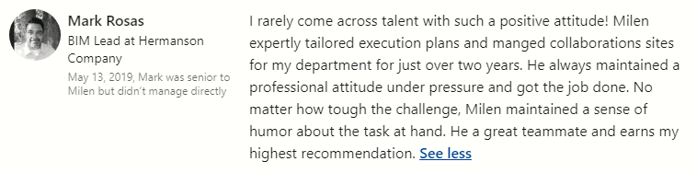

ESTIMATOR | SUPERINTENDENT | ARCHITECT @
ENGINEERING SYSTEMS, Sofia, Bulgaria 2014-2015
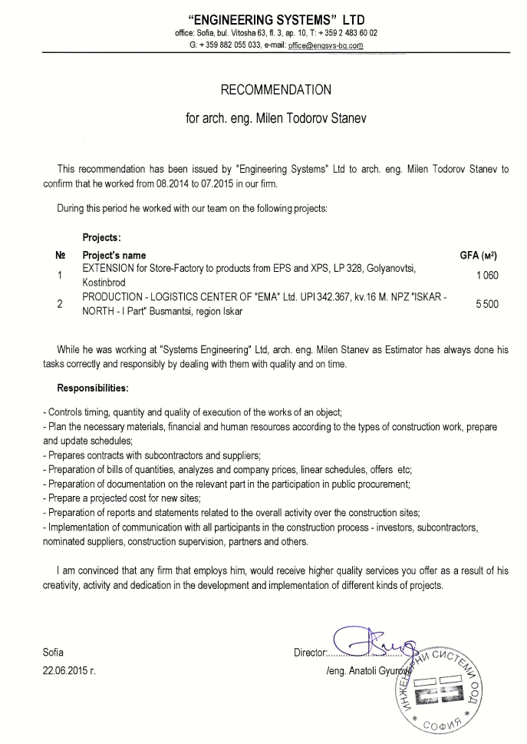

ESTIMATOR | SUPERINTENDENT | ARCHITECT @
PROJECT ARCHITECT @ BUREAU VASILEV, Sofia, Bulgaria 2009-2013

