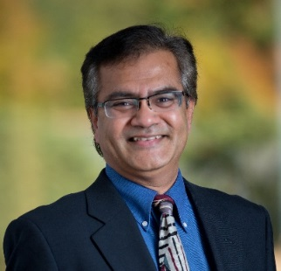
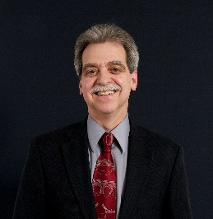
Samir Mokashi | Principal, Code Unlimited LLC
Samir completed his Masters in Architecture at University of Oregon and joined IDC, an A/E firm recognized as the world leader in semiconductor facility design, in 1992. There he soon built a name for himself as the go to hazardous materials code expert. Not satisfied, in 2006 he left IDC to found Code Unlimited. His success caught the attention of the CEO of Evergreen Engineering an AE firm focused on semiconductor market; which lead to formation and rapid growth of a code department within Evergreen. Six years later Samir left Evergreen to restart Code Unlimited as an independent code consulting company. Code Unlimited took off right away and is now recognized as the preeminent code consulting firm in the Pacific Northwest, with offices in Portland, Seattle, Bend, and an emerging office in Troy NY. In 2015 Code UL was recognized by the Portland Business Journal as the 36 fastest growing private firm in Oregon and southwest Washington.

Samir has a unique ability to deliver simple and elegant solutions to problems that stump most others. His positive attitude of “glass half full” permeates in his interaction with friends, associates, customers and jurisdictions. The depth of his knowledge and strong communication skills has earned him wide respect from city and state officials, as well as designers and owners. He has been involved in developing local and national building codes, is a sought after speaker, and a highly valued mentor to young professionals. His code classes have enlightened many students, professionals, owners, contractors, code officials, and an occasional innocent bystander.

